FMTA February Newsletter
February 19, 2025
General Meeting: 9:30 a.m.
Master Class with Dr. Lei Weng at 10:30 a.m.

Location: Our Savior’s Church
1975 Garrison St., Lakewood CO 80227

Sonatina Festival-March 8th
*Location TBA…stay tuned!!!
**ONLINE REGISTRATION IS OPEN for FMTA’s 2025 Sonatina Festival. All registrations for teachers, student performers, and payments via PayPal are due by February 8, 2025. Questions can be emailed or texted to Mollie Yoder (mollie@marigoldmusic.studio or 651-269-5834).

Review Standing Rules here:
https://www.fmtamusic.org/wp-content/uploads/2024/02/101823SFApprovedStandingRules.pdf

Review Current Required Piano Repertoire here:

https://www.fmtamusic.org/wp-content/uploads/2024/11/2024Sonatina-Repertoire.pdf

Submit Teacher Registrations here:
https://docs.google.com/forms/d/e/1FAIpQLSeILb4mnDjPHpfivIxkPdXXsgNf5jiTBeDcBsjzQhd5gyrrRg/viewform

Submit Student Registrations here:
https://docs.google.com/forms/d/e/1FAIpQLSf-1WI6eRANygNVBTv-pMRxDN9WygH0AusZwrr1hWqphuawnA/viewform

Submit Payment by PayPal here. Note that the payment option is at the bottom of the page: https://www.fmtamusic.org/sonatina-festival/
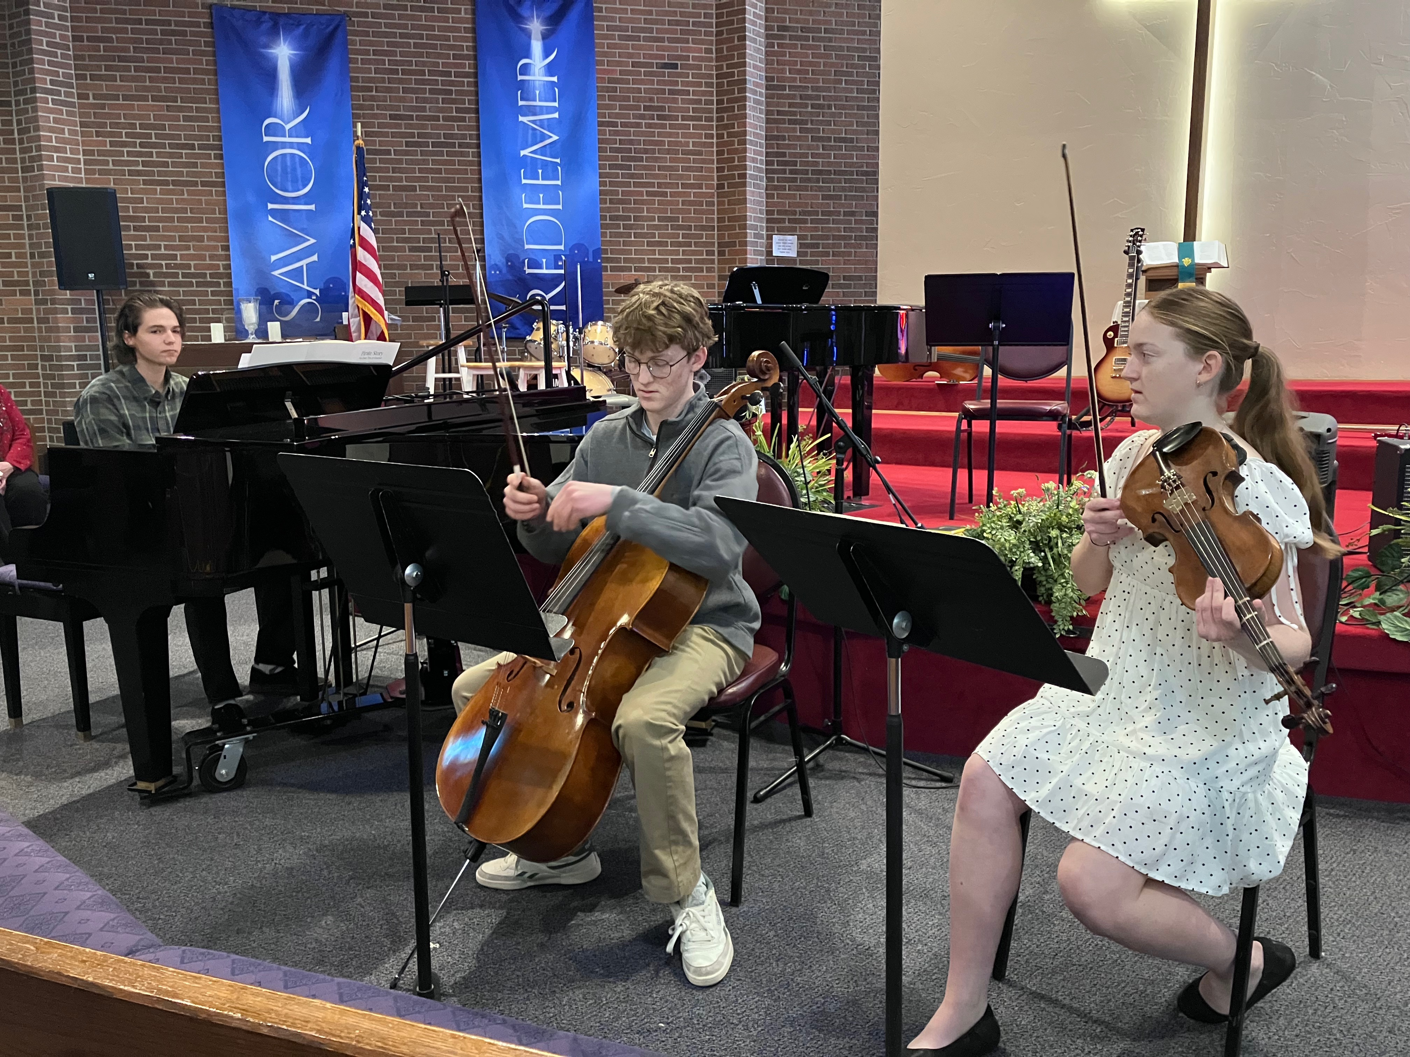
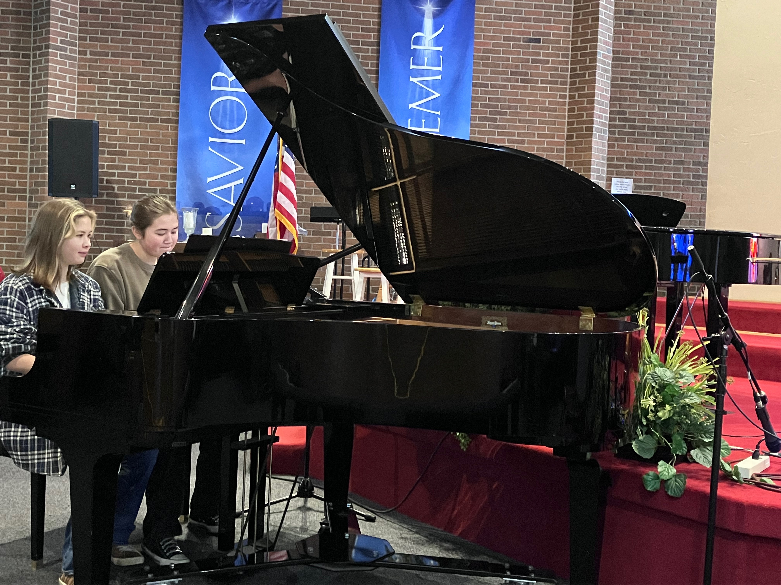

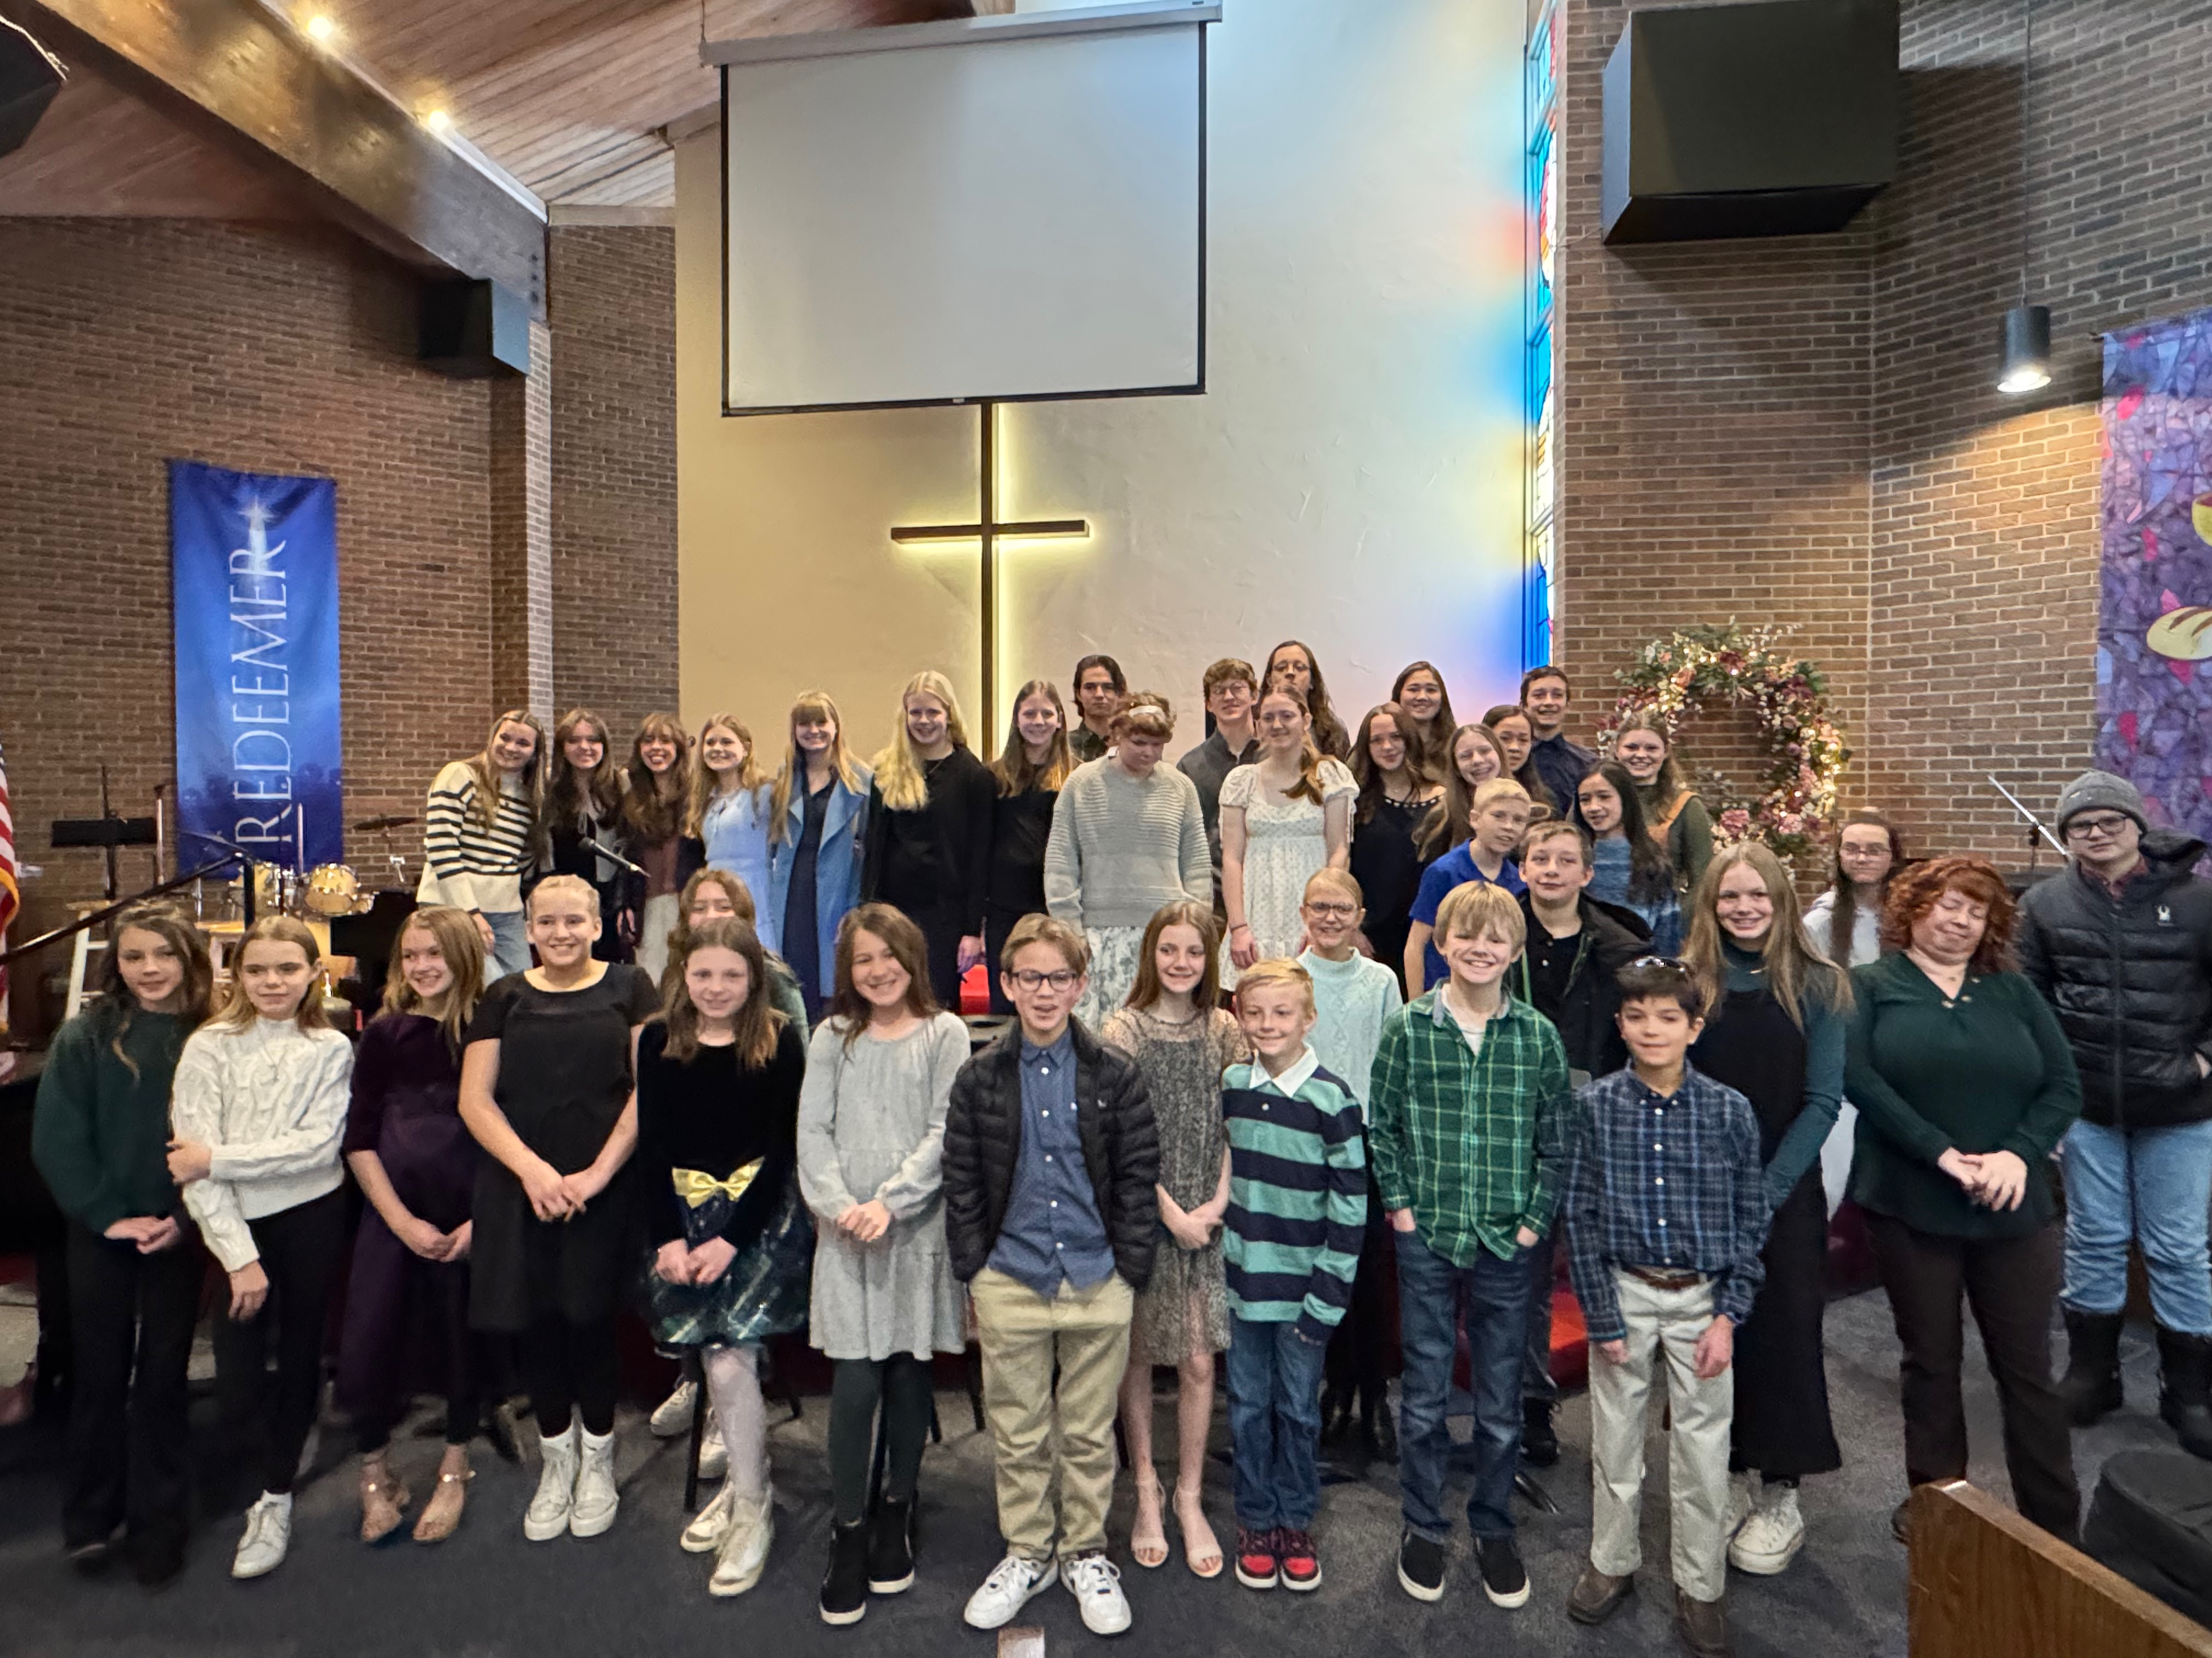

Winterfest was a huge success last weekend! We heard piano, strings, horns, guitars and vocals-so many amazing ensembles and performers. Thank you to April Larsen for chairing this event!

2026 Sonatina Festival News:
**We are looking for a 2026 Sonatina Festival Chair…it is not a solo act and there is plenty of support along the way! Please contact Thomas Hoops if you are even a little bit interested. Thank you!
PRP: FMTA Book Discussions 2024-2025
Effortless: Make it Easier to Do What Matters Most
by Greg McKeown – Copywrite 2021
ISBN- 978-0593135648 (Hardcover) Also check (ebook)
crownpublishing.com/Penguin Random House LLC, NY

Discussion Dates:
February 26, 2025 – Part III – Effortless Results
Time: 9:30-11:00 a.m.

Please RSVP for discussions. Home Studio of Arlyce Black 303-795-8162, Cell/Text 303-829-0179

COMMUNITY
Colorado Peaks Piano Competition
Registration is NOW OPEN for the brand new Colorado Peaks Piano Competition occurring on Saturday, March 22, 2025 at Colorado Christian University! This event is being co-chaired by Amy Lee and Aaron Stampfl and will take place in CCU's new music building, the Armstrong Center. There are four age-based divisions with cash prizes, and the registration deadline is February 8, 2025.

For further guidelines and registration details, please visit the competition website:
www.coloradopeakspianocompetition.com

For any questions, please email copeakspianocompetition@gmail.com.
Amy Lee
Co-Chair, 2025 Colorado Peaks Piano Competition

**Please see attached flyer in email.

Adult Student Recital Event
Altitunes is hosting an adult student recital called Coffee and Music! Students from any studio are welcome to participate. This will be a low pressure, informal event just for adult music learners. All instruments and levels are welcome! Coffee and pastries will be served :).
*teachers will not be permitted to advertise or recruit students at this event.

Dates: Saturday April 19, 2025
Time: 10am
Location: Altitunes Lakewood (1075 S. Yukon St. 80226)

Equipment provided: grand piano, keyboard, music stand, chairs. Please bring any amps, mics/stands needed for performance.

Cost: $20/performer
Register here: https://altitunes.opus1.io/w/coffeeadnmusic
Contact Amy with questions: amy@altitunes.net

Do you have an announcement for the monthly newsletter?
Please email davina.perret@gmail.com by the first of the month to have
it included in the next edition.

